Background
BedZED was designed by the architect Bill Dunster to be carbon neutral, protecting the environment^{[1]} and supporting a more sustainable lifestyle. The project was led by the Peabody Trust in partnership with Bill Dunster Architects, Ellis & Moore Consulting Engineers, BioRegional, Arup and the cost consultants Gardiner and Theobald. The project was also pioneering by being the first construction project where a local authority sold land at below market value to make sustainable economically development viable.^{[1]}
The 82 homes, and 1,405 square metres (15,120 sq ft) of work space were built in 2000–2002. The project was shortlisted for the Stirling Prize in 2003.

Transport
Because of BedZED's low-energy-emission concept, cars are discouraged; the project encourages public transport, cycling, and walking, and has limited parking space. There are good rail and bus links in the immediate area.

Principles
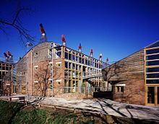
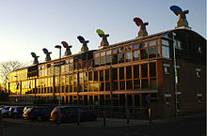
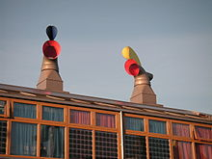

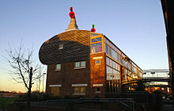

- Zero energy—The project is designed to use only energy from renewable sources generated on site. There are 777 square metres (8,360 sq ft) of solar panels. Tree waste fuels the development's cogeneration plant (downdraft gasifier) to provide district heating and electricity. The gasifier is not being used, because of technical implementation problems, though the technology has been and is being used successfully at other sites.
- High quality—The apartments are finished to a high standard to attract the urban professional.
- Energy efficient—The houses face south to take advantage of solar gain, are triple glazed, and have high thermal insulation.
- Water efficient—Most rain water falling on the site is collected and reused. Appliances are chosen to be water-efficient and use recycled water when possible. A "living machine" system of recycling waste water was installed, but is not operating.
- Low-impact materials—Building materials were selected from renewable or recycled sources within 35 miles (56 km) of the site, to minimize the energy required for transportation.
- Waste recycling—Refuse-collection facilities are designed to support recycling.
- Transport—The development works in partnership with the United Kingdom's leading car-sharing operator, City Car Club. Residents are encouraged to use this environmentally friendly alternative to car ownership; an on-site selection of vehicles are available for use.
- Encourage eco-friendly transport—Electric and liquefied-petroleum-gas cars have priority over cars that burn petrol and diesel, and electricity is provided in parking spaces for charging electric cars.
- A higher reported quality of life, with a strong sense of community

Performance
Monitoring conducted in 2003 found that BedZED had achieved these reductions in comparison to UK averages:
- Space-heating requirements were 88% less.
- Hot-water consumption was 57% less.
- The electrical power used, at 3 kilowatt hours per person per day, was 25% less than the UK average; 11% of this was produced by solar panels.^{[3]} The remainder normally would be produced by a combined-heat-and-power plant fueled by wood chips, but the installation company's financial problems have delayed use of the plant.
- Mains-water consumption has been reduced by 50%, or 67% compared to a power-shower household.
- The residents' car mileage is 65% less.

Problems
A review of the BedZed development in 2010 drew mainly positive conclusions. Residents and neighbours were largely happy. However, a few significant failures were highlighted, for example:
- the biomass wood chip boiler (biomass gasifier) was no longer in operation and the back up power source, a gas boiler, was now used.] The downdraft wood chip gasifier CHP (combined heat and power) had reliability problems due to technical failures and the intermittent schedule of operation (no night time operation) imposed by the local authority.
- the 'Living Machine' water recycling facility had been unable to clean the water sufficiently. The cost of the facility also made it unviable.
- the passive heating from the sunspaces had been insufficient
- despite best efforts, residents were on average still leaving an ecological footprint of 1.7 planets, which is more than the target of 1.0 planet (but much less than the UK average of 3 planets).
- How can BedZED be described as a “sustainable urban development”?
- What facts and figures can be used to back up this comment?
- How successful has the project been?
- What facts and figures can be used to back up your opinion?
- Draw a model BedZED house, be sure to add in all the sustainable features.
- If you were to design a “sustainable urban development” what would you do better than BedZED?

