The Living World Homework Booklet
 | Topic | Score /10 | Targets/comments
Ecosystems | 2.1. Background to Ecosystems
 | 2.2 The distribution and characteristics of large scale natural global ecosystems.
Tropical rainforests | 2.3 Tropical rainforest ecosystems have a range of distinctive characteristics.
 | 2.4 Deforestation has economic and environmental impacts.
 | 2.5 Changing rates of deforestation.
 | 2.6 The Amazon - A case study of a tropical rainforest.
 | 2.7 Tropical rainforests need to be managed to be sustainable.
Cold Environments | 2.8 Characteristics of a cold environment – climate, permafrost, soils, plants and animals.
 | 2.9 Vegetation and animal adaptations to the physical conditions.
 | 2.10 The development of cold environments creates opportunities and challenges.
 | 2.11 Alaska and Yukon CASE STUDY
2.12 Wilderness
2.13 Cold environments are at risk from economic development.
 | 2.14 Antarctica EXAMPLE balancing economic development and conservation in cold environments | Revise for test

Remember to read the relevant pages in your cool geography textbook or on the website BEFORE you do your homework

Homework 2.1 The Background to Ecosystems (READ pages 2 to 4)
- Draw a simple food web for your back garden or a local park.

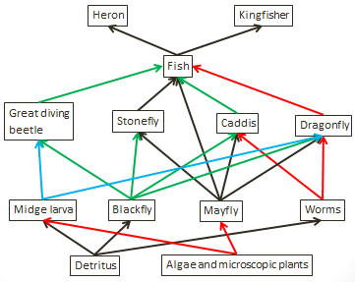
- What would happen to the pond ecosystem if insects like rat tailed maggot and great diving Beatles were wiped out?
- Should we protect native British species against invasive species? Justify your view.
10
9
8
7
6
5
4
3
2
1
0

Homework 2.2 – the Distribution of Ecosystems (READ pages 5 to 6)
- Which ecosystem would you most like to visit and why?
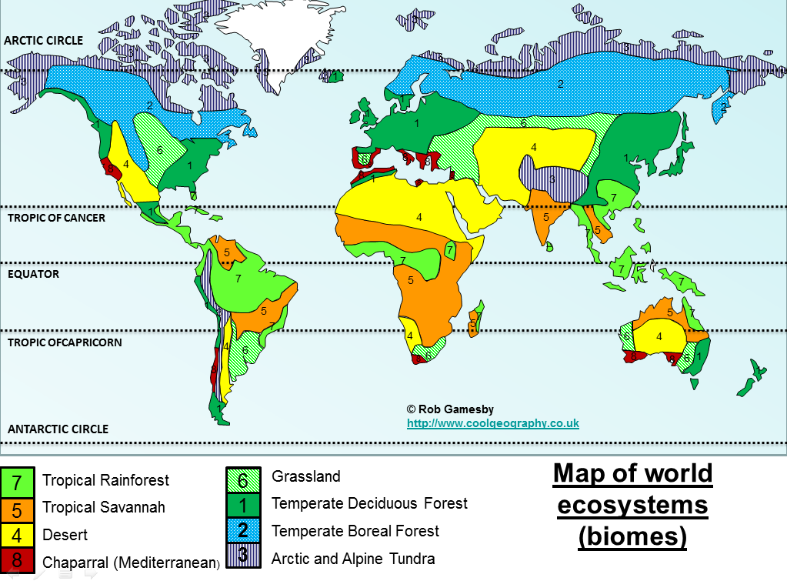
- Describe the distribution of temperate deciduous forests using the map below

- Explain why temperate deciduous forests are found where they are.
10
9
8
7
6
5
4
3
2
1
0

Homework 2.3 – Tropical Rainforest Characteristics (READ pages 7 to 11)
            - Make a mind map of all 6 of the factors that affect tropical forests

Factors affecting tropical rainforests

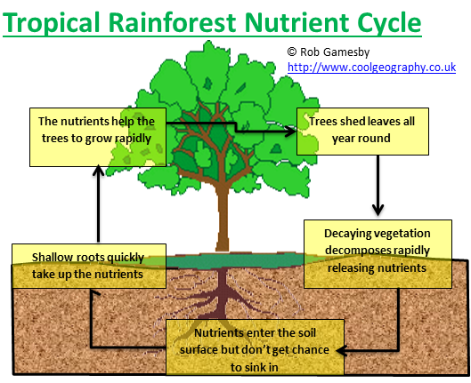
- What would happen to the nutrient cycle if tropical trees are cut down?
- Rank the six factors that affect tropical forests in an order of importance from 1 to 6. Justify your ranking.
10
9
8
7
6
5
4
3
2
1
0
Factor | Rank
Climate
Soils and nutrients
Water Cycling
Adaptions of plants and animals
Competition
People

Homework 2.4 – Impacts of deforestation (READ page 12)
- List as many environmental and economic impacts of tropical rainforest clearance as possible
Economic | Environmental

- Annotate the photograph to show the features of and the damage done by, slash and burn agriculture

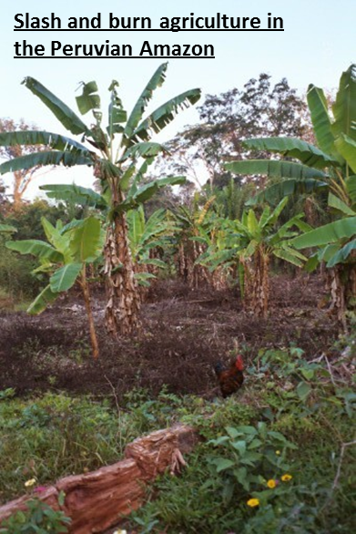

10
9
8
7
6
5
4
3
2
1
0

Homework 2.5 – Rates of deforestation (READ page 13)
Country | % forest cover 2005 | % change 1990 to 2005
Bolivia | 54 | -7
Brazil | 57 | -8
Brunei | 53 | -11
Cambodia | 59 | -19
Colombia | 59 | -1
Congo | 66 | -1
Guatemala | 36 | -17
Indonesia | 49 | -24
Madagascar | 22 | -6
Nigeria | 12 | -36
Panama | 58 | -2
Papua New Guinea | 65 | -7
Peru | 54 | -2
Senegal | 45 | -7
Sri Lanka | 30 | -18
Mean
Mode
Median
- Study the data in the table opposite
- Identify the country with the greatest loss in forest cover between 1990 and 2005.
- Which country had the least forest cover in 2005?
- Which country had the most forest cover in 2005?
- What is the range for % forest cover in 2005? (subtract the smallest value from the largest value)
- Calculate the mean, mode and median for the data shown. Add these to the table.
- Draw a dispersion graph of the % forest cover data using the template provided below.
- Add on the upper and lower quartiles

Help Box
Measures of central tendency
Mode - Mode is the value that appears the most times
Mean – add all of the values in the column together and divide by the number of results, in the case 15
Median – rank the results in order from smallest to biggest. The median is the middle value on the list. In this case the 8th result in your list.
Inter Quartile Range
Upper quartile (UQ) = Number of results (15)+1/4 x3
Lower quartile (LQ)= number of results (15) +1 /4
IQR = Upper Quartile – Lower Quartile

10
9
8
7
6
5
4
3
2
1
0

Homework 2.6 – Deforestation Case study (READ pages 14 to 16)
- Define the term deforestation
- Should countries develop and deforest parts of the Tropical rainforests? Discuss with reference to a case study you have studied (9 Marks + 3 SPGST)
10
9
8
7
6
5
4
3
2
1
0

Homework 2.7 – Sustainable rainforest management (READ pages 17 to 18)
Design a poster aimed at helping people understand deforestation and what can be done to help save the tropical rainforest. Include factual evidence, pictures and diagrams in your poster.

10
9
8
7
6
5
4
3
2
1
0

Homework 2.8 – Cold environment Characteristics - (READ pages 19 to 21)
1.Look carefully at the climate graph for McMurdo Research Station in Antarctica
- Complete the graph by adding the information below
Month | Precipitation amount
November | 10
December | 15
- What is the lowest temperature in McMurdo Research Station?
- What is the highest temperature in McMurdo Research Station?
- Now calculate the range of temperatures (highest – lowest)
- Outline the differences between polar environments and tundra environments
- Research how one group of people survives in a Tundra environment
10
9
8
7
6
5
4
3
2
1
0

Homework 2.10 The development of cold environments creates opportunities and challenges.
- (READ pages 26 to 28)
Complete the table below
10
9
8
7
6
5
4
3
2
1
0
How it makes life difficult in cold environments
Extreme temperatures
Permafrost
Inaccessibility
Infrastructure and buildings

Homework 2.11 –Alaska and Yukon CASE STUDY (READ pages 29 to 33)
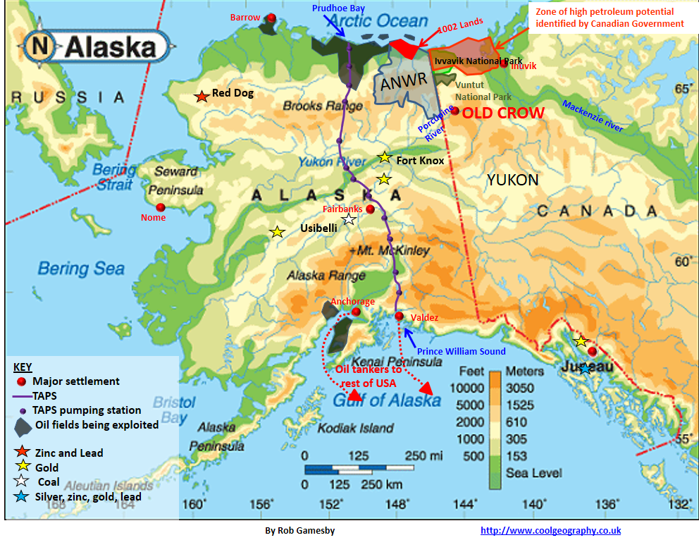
- Describe the location of resources in Alaska and the Yukon

- Explain how the trans Alaska pipeline works
- What impact does the oil industry have on people and the environment?
Environment
People
People
10
9
8
7
6
5
4
3
2
1
0

- Explain what you would do as a tourist in Alaska

COPYRIGHT NOTICE
This document is the copyrighted property of Robert Gamesby and http://www.coolgeography.co.uk
This document can be copied, revised, customised and used for the use of a PAID SUBSCRIBING SCHOOL ONLY under the conditions of the School Subscribers Agreement found at http://www.coolgeography.co.uk
PROHIBITED USES
The School shall not and shall procure that each and every Authorised User within their school does not:
- Copy, print out or otherwise reproduce any Resources (in whole or part) for any commercial use or any of purpose except as permitted under the School Subscribers Agreement or authorised in advance by Http://www.coolgeography.co.uk in writing;
- Mount or distribute any part of the Resources on any electronic network, including TES resources, Nings, file sharing sites etc.
- Remove or alter any copyright notices or means of identification or disclaimers as they appear in the Resources. This includes the BACKGROUNDS of PowerPoints which have a copyright notice on them.
NOTE
I have spent hundreds of hours putting the resources together, please respect my work!

