Create some picture flash cards to help you remember these keywords.
Make notes about equality in the Gurdwara. These sites will help.
http://www.bbc.co.uk/schools/gcsebitesize/rs/prejudice/sikhismrev4.shtml
http://www.bbc.co.uk/religion/religions/sikhism/ritesrituals/gurdwara_1.shtml

Omnipotent: God is all powerful
Omniscient: God is all knowing
Omnibenevolent: God is all loving
Omnipresent: God is all seeing/everywhere
This site will help you define the words and make notes on the problem of suffering. https://hgsrs.wordpress.com/about/the-problems-of-evil-and-suffering/the-problem-of-suffering/
Use this site to make notes on free-will and original sin.
http://www.bbc.co.uk/schools/gcsebitesize/rs/god/chgoodandevilrev2.shtml
Examples of natural and moral evil: (which is which?)
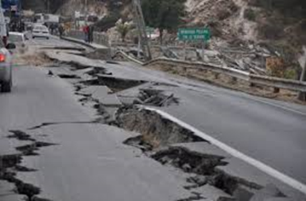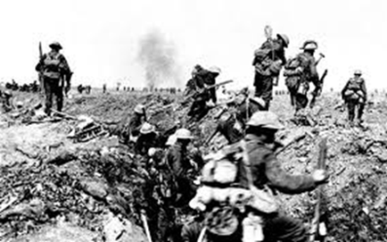
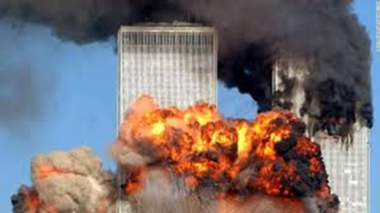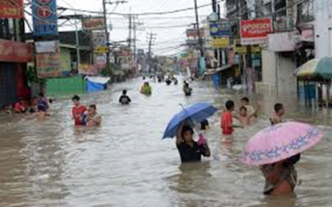
The 5 Ks- Watch this video to fill in the table below.
http://www.bbc.co.uk/education/clips/zcn34wx
Name: | Description: | Reason:

